313601
Type of Identification:

Driver's License:
State: | Checked By:

LAST NAME |  |  |  | FIRST NAME |  |  | MI | Check Your Skier Type  I II III  Refer to the back of the form for a complete description of skier types.
ADDRESS
CITY |  |  |  |  | ST | ZIP
PHONE |  |  | E-MAIL ADDRESS |  |  |  |  | Helmet Number | Declined - Initials
 |  |  |  |  |  |  |  | Helmet Size | Tech Initials
Weight: | lbs. | Height: | ft. in. Age: | M/F | Shoe Size:
Acknowledgement of Personal Information & Equipment Instructions

I have accurately represented the above listed information and it is true and correct. I will not use any equipment to be provided to me during this transaction until I have received instruction on its use and I fully understand its use and function. I agree to verify that the visual indicator settings to be recorded on this form for downhill ski equipment agree with the number appearing in the visual indicator windows of the equipment to be listed on this form.
Equipment User's Signature: Parent/Guardian Signature:

If a minor, signature of parent or guardian is required.
The signature of one parent or guardian binds both parents concerning any losses they might have.

Boot Size | Boot # |  |  | Boot Sole Length | Synchro # | Tech Initials
Size | Ski/Snb./Skiboard # |  |  | LT | LH | Code
Stance  Regular / Goofy |  | Poles | Tech Init. | RT | RH | Tech Signature
Equipment Rental & Liability Release Agreement
1. I accept for use AS IS the equipment listed on this form and accept full financial responsibility for the care of the equipment while it is in my possession. I will be responsible for the replacement at full retail value of any equipment provided under this form, but not returned to the shop. I agree to return all rental equipment
by the agreed date and time.
2. I understand that the ski/boot/binding systems cannot guarantee the user's safety. In downhill skiing, the binding system will not release at all times or under all circumstances where release may prevent injury or death, nor is it possible to predict every situation in which it will release. In snowboarding, cross-country
skiing, skiboarding, snowshoeing and other sports utilizing equipment with non-releasable bindings, the binding system will not ordinarily release during use;
these bindings are not designed to release as a result of forces generated during ordinary operation.
3. I understand that the sports of skiing, snowboarding, skiboarding, cross-country skiing, snowshoeing and other sports, including the use of lifts (collectively “RECREATIONAL SNOW SPORTS”) involve inherent and other risks of INJURY and DEATH. I voluntarily agree to expressly assume all risks of injury and
death that may result from these RECREATIONAL SNOW SPORTS, or which relate in any way to the use of this equipment to be issued to the user.
4. I understand that a helmet designed for RECREATIONAL SNOW SPORTS use will help reduce the risk of some types of injuries to the user. I recognize that serious injury or death can result from both low and high energy impacts, even when a helmet is worn.
5. I AGREE NOT TO SUE AND TO RELEASE, Ski Liberty Operating Corp., Ski Roundtop Operating Corp., Whitetail Mountain Operating Corp., Snow Time Inc., Peak Resorts, Inc., and Vail Holdings, Inc., including their agents and employees, as well as the equipment manufacturers and distributors and their successors in interest (collectively “PROVIDERS”), from all liability for injury, death, property loss or damage (past, present, and future), that in any way results from the use of facilities or participation in recreational snow sports or is in any way related to the use of the equipment issued to the user, including any liability that results from the NEGLIGENCE OF PROVIDERS or any cause for which a release is enforceable by law.
6. I further agree to hold harmless, defend and indemnify PROVIDERS for any loss or damage, including any that results from claims or lawsuits for personal injury, death, property loss or damage related in any way to the use of this equipment.
7. I agree that all disputes arising under this contract for use of rental equipment as described on this form, or the use of the facilities at Liberty Mountain Resort, Roundtop Mountain Resort and Whitetail Resort shall be litigated exclusively in the Court of Common Pleas of the county in which the incident occurs or in the United States District Court for the Middle District of Pennsylvania.
8. I grant permission for the Ski Area to use my photograph, videotape, motion picture recording or any other record of my use of its facilities for legitimate purposes.
9. This agreement is governed by the applicable law of the Commonwealth of Pennsylvania. If any provision of this agreement is determined unenforceable, all
other provisions shall be given full force and effect.
I Have Read and Understand This Equipment Rental & Liability Release Agreement.
User's Signature: Date:
If a minor, signature of parent or guardian is required.
Parent/Guardian: If equipment user is a minor, I verify that I am the parent or guardian of the minor, and I have authority to enter into this agreement on behalf of the equipment user and I agree to be bound by the terms and conditions of this agreement.

Parent/Guardian's Signature:
The signature of one parent or guardian bind both parents concerning any losses they might have.
Date:

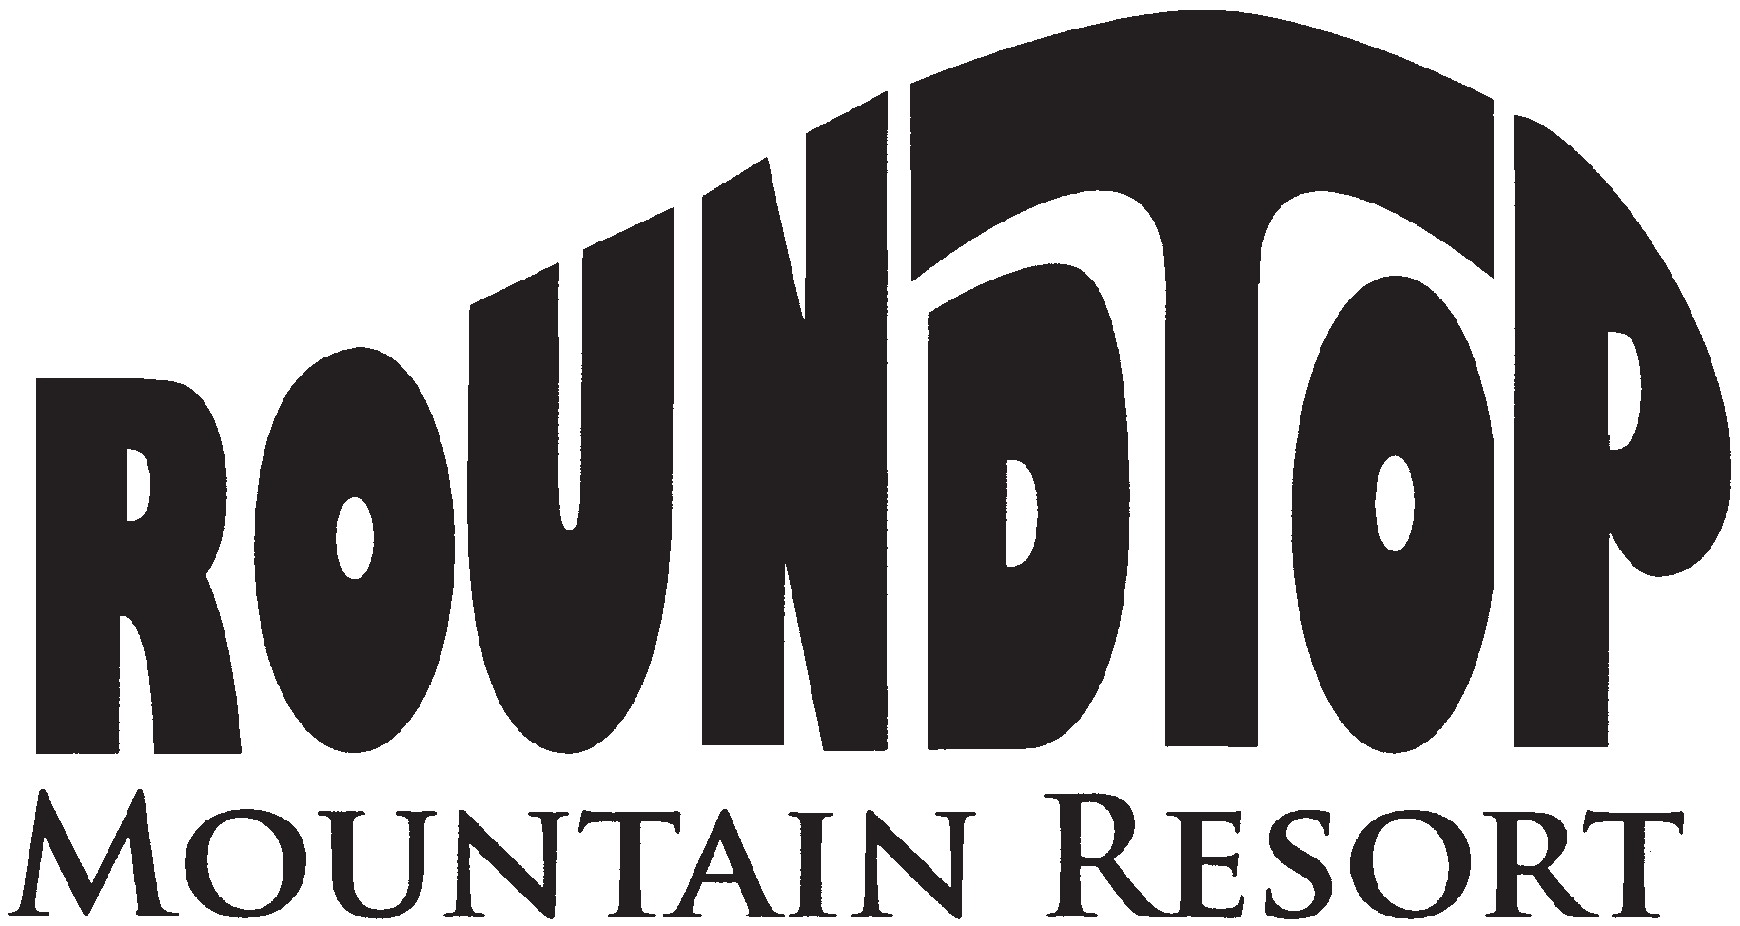
SK01 (REV. 09/19)

MARGINAL WORDS

0 0 0 0 0 0 0 0 0 0 0 0 0 0 0 0 0

Classify Yourself
DETERMINING YOUR SKIER TYPE IS YOUR RESPONSIBILITY

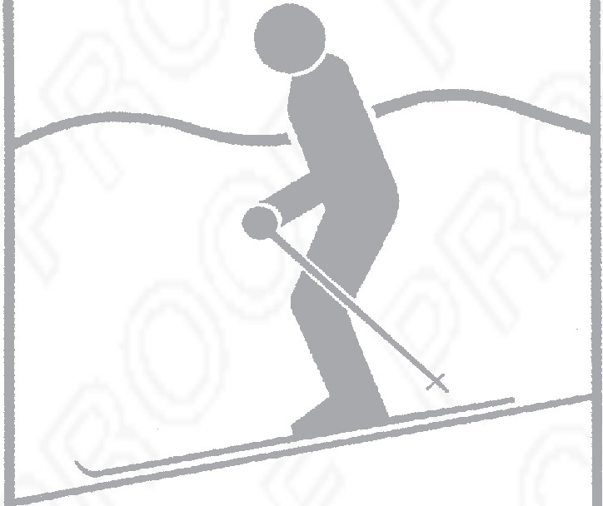
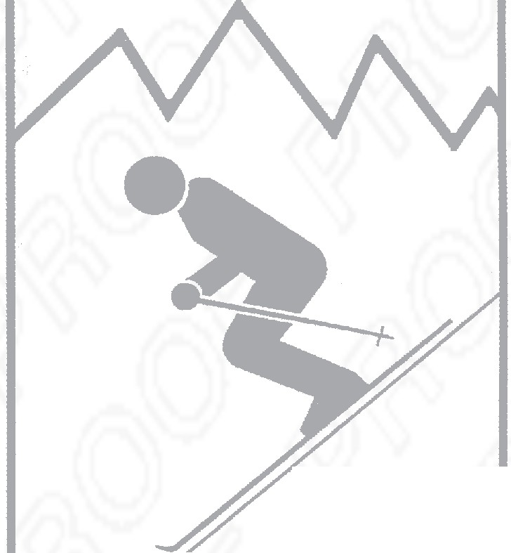
Your Skier Type, height, weight, age, and boot sole length are used by the shop technician to determine the release/retention settings for your bindings. Consult these descriptions to select your classification. Be sure to provide accurate information. Errors may increase your risk of injury.

 | Skiers not classified as Type I or III  Type II  Skiers who designate themselves as Type II receive average release/retention settings  appropriate for most  recreational skiing. | Type III  Fast skiing on slopes of moderate to steep pitch  Skiers who designate themselves as Type III receive higher than average release/retention settings. This corresponds to decreased release-ability in a fall in order to gain a decreased risk of inadvertent binding release.  (This classification is not recommended for skiers under 481bs.)
Type I
Cautious skiing on smooth slopes of gentle to moderate pitch

Skiers who designate themselves as Type I receive lower than average release/retention settings. This corresponds to an increased risk of inadvertent binding release in order to gain release-ability in a fall. This type also applies to
entry-level skiers uncertain of their classification.

If from experience, you have been dissatisfied with the release/retention settings that result from your skier classification, mention this to your binding technician.

